Os cálculos a seguir foram referenciados no aplication notes da Texas Intruments:

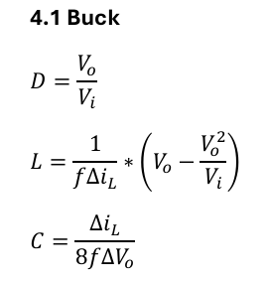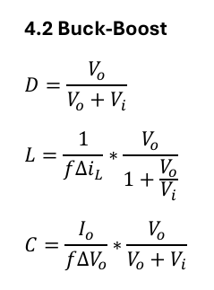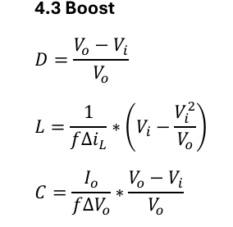

1. Design

* Input Voltage Range: Vi = [18,30] V
* Duty Cycle Range D = [0.2,0.85]
* Output Voltage: Vo = [1 – 55] V (Variável)
* Output Current: 2A
* Switching Frequency: f = 10kHz
* Inductor current ripple: 0.6 (30%)
* Output Voltage Ripple: 1V (variável)

1. Operating Mode

|  |  |  |  |
| --- | --- | --- | --- |
| Mode | Vi | D | Vi/Vo |
| Buck | [25 - 30] | [Vo/Vi] | 25/Vo (1.10) |
| Buck-Bost | [22 - 25] | [Vo/(Vo+Vi)] | - |
| Boost | [18 - 22] | [(Vo-Vi)/Vo] | 22/Vo (0.9) |

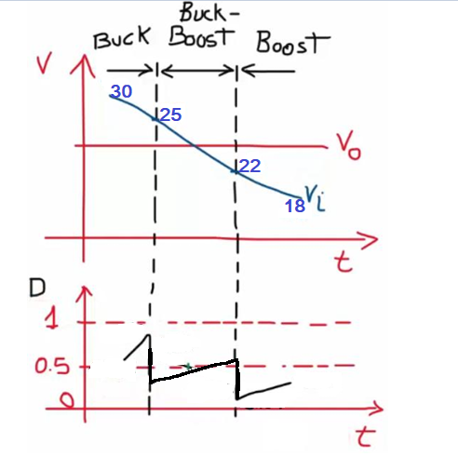

1. Inductor and capacitor Buck

Vomax = 27V

VoMin = 1V

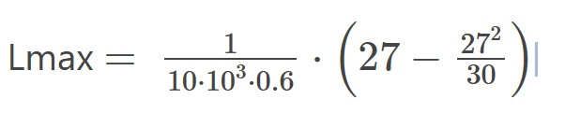

Lmax = 0.00045

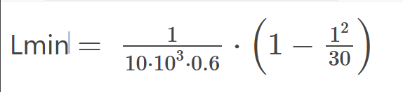

Lmin = 1.61x10^-4

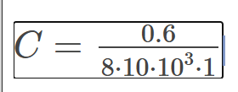



* 1. Inductor and capacitor Buck Boost

VoMax = 25

VoMin = 22